Python 

Advantages of this language

Execution of code

input() or raw_input()

Built in functions

print()-usages and different types that we can use

<https://www.w3resource.com/python/python-print-statement.php>

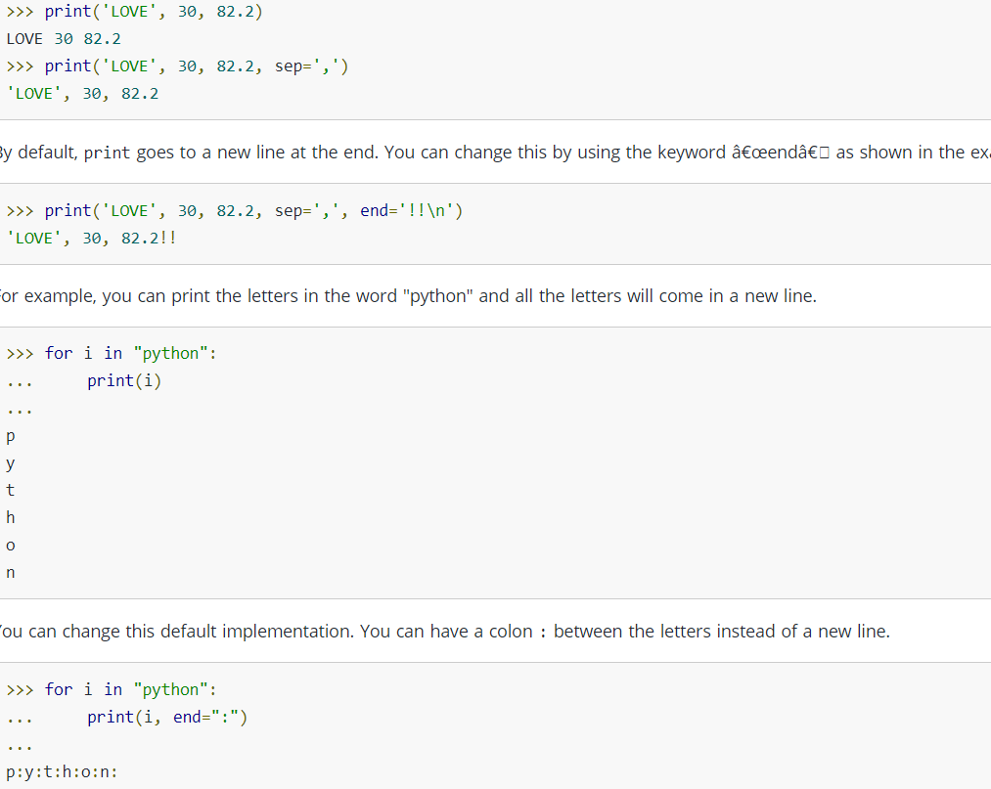

Variable s